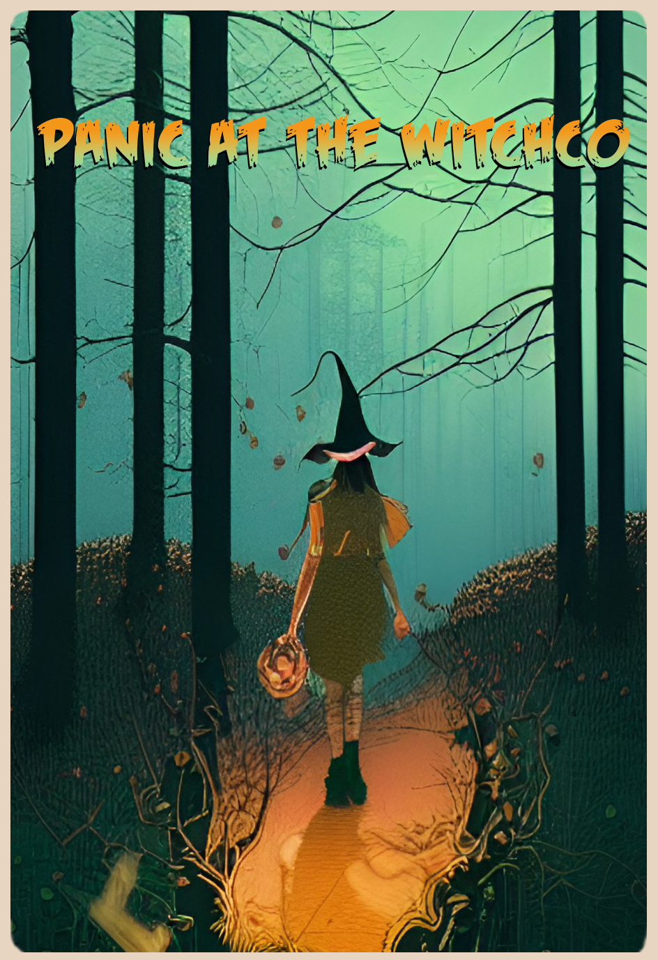

By: Lucy Coates

By: Lucy Coates

Table of Contents

# Contents

[Contents 2](#_Toc116839855)

[Story 3](#_Toc116839856)

[Reference 4](#_Toc116839857)

[Environment 4](#_Toc116839858)

[Setting 5](#_Toc116839859)

[Characters 6](#_Toc116839860)

[Features 7](#_Toc116839861)

[Style 8](#_Toc116839862)

[Program/Requirements/Features/Gameplay 9](#_Toc116839863)

[Area 1 – Outside 9](#_Toc116839864)

[Area 2 – Main Room 9](#_Toc116839865)

[Area 3 – Hidden Dungeon 9](#_Toc116839866)

[Diagrams 10](#_Toc116839867)

[Bubble Diagrams 10](#_Toc116839868)

[Area 1 - Outside 10](#_Toc116839869)

[Area 2 – Main Room 10](#_Toc116839870)

[Area 3 – Hidden Dungeon 10](#_Toc116839871)

[Metrics 11](#_Toc116839872)

# Story

Deep in the whistling woods lies a quaint cabin resting against a great mountain belonging to the witch Marigold Le Fae. The cabin has a unique beauty to it whether it be the location it sits in or the well-tended garden which lures any traveler lost in the whistling woods to its doorstep. Marigold attracts travelers to stay the night so she could capture their souls to fuel her magic and keep herself youthful. However, Marigold is a very ambitious witch and picked off more travelers than she should have and caught the attention of witch hunters. Upon her cabin being raided by witch hunters, she had to take shelter within her panic room, but she left her hidden bookshelf door open which gives the witch hunters free rein of her cabin. Marigold must scry from within her panic room and use the magic and potions they have in store to deter the witch hunters and stay safe even though she was stealing the souls from innocent travelers, but which witch hasn’t done that before. She must stay safe and use her wits to not be found out by the witch hunters and who knows apparently witch hunters have strong souls.

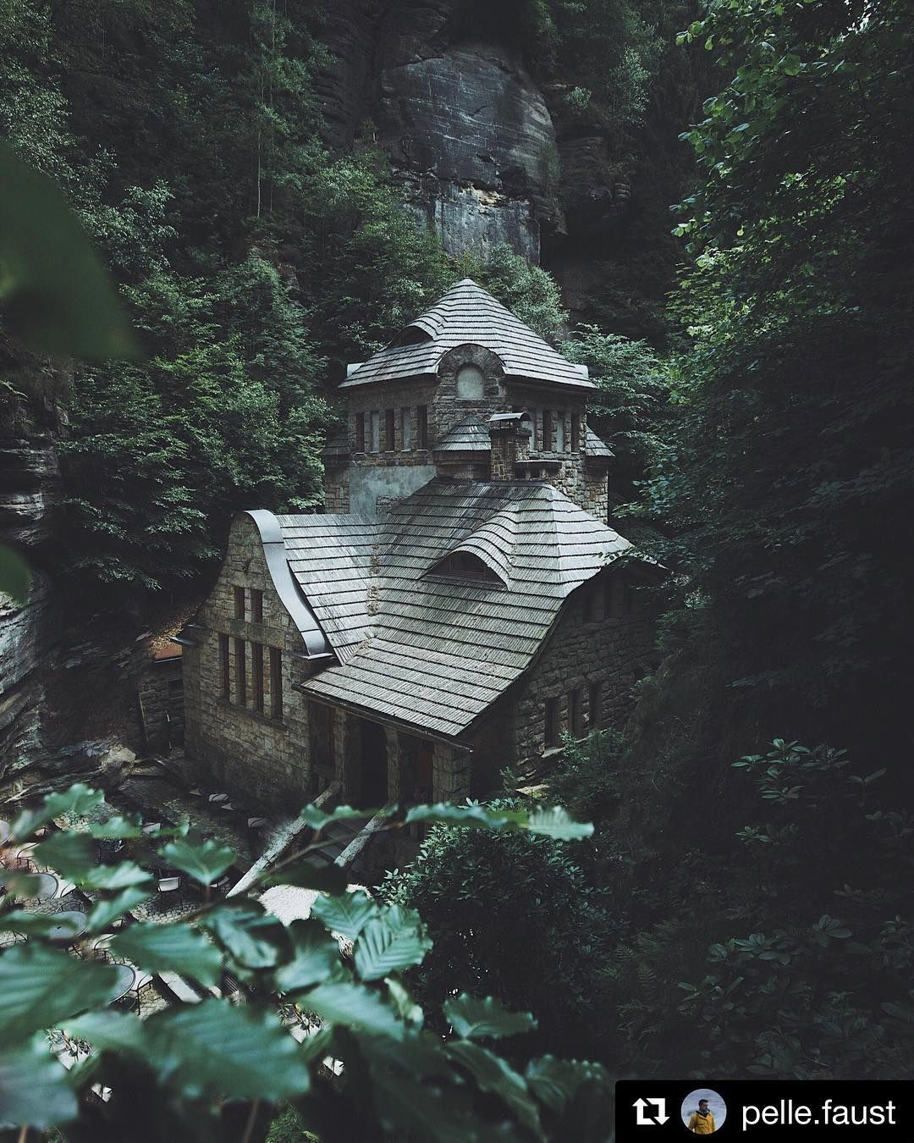

Figure -Outside of the cabin

# Reference

## Environment

|  |  |  |
| --- | --- | --- |
| Foggy Mountain Forest - Stock Photos | Motion Array  Figure - The mountain that towers over the cabin | | |
| There's a Real-Life Enchanted Forest and It's In Dartmoor, England »  TwistedSifter  Figure - The forest surrounding the cabin and mountain | A Dream of an Encounter | Magical places, Abandoned places, Landscape  Figure - The forest is filled with ruins of long past civilizations |  |

## Pin em Go Girl!!Setting

|  |  |
| --- | --- |
| The Hobbit: The road goes ever on  Figure - The world is high fantasy taking inspiration from middle earth | 20 Pics Of Abandoned Witch Cottages That'll Make Your Inner Witch Happy  Figure - The housing is very rustic and storybook |
| 47 best images about Witch room on Pinterest | Witch room, Wood ... | Scary  halloween decorations, Halloween decorations indoor, Halloween decorations  Figure - With all the beauty there is a creepy dark magic side to the world | Figure - The forest surrounding the cabin is enchanted to look more welcoming than what it is |
| Figure - Magic exists in this world but corrupts those who use it | |

## Characters

|  |  |  |  |
| --- | --- | --- | --- |
| Figure - A witch being hunted by a witch hunter | | Cats and Witches: A Magical History | The Alchemist's KitchenFigure - A witch with her familiar(s) | |
| Figure - The witch of the woods  Marigold Le Fae | No photo description available.  Figure - Marigolds familiar Flora | | Witch Hunter by cwalton73 on DeviantArt  Figure – The serious and stubborn witch hunter |

## Features

|  |  |
| --- | --- |
| Garden in the forest, a secret garden sanctuary with flowers and veggies | Forest  garden, Secret garden, Dream garden  Figure - The garden outside the cabin which grows herbs that marigold uses | Creating a Stylized Witch Hut Interior in UE4  Figure - The furnishing of the main area makes it look like a standard rustic cabin |
| Witch Alchemy Room by FauxH0und on DeviantArt  Figure - Inside the mountain that backs the cabin holds the witches alchemy area where she does her potion making and magic | The Wizards Chamber  Figure - Panic Room using the walls of the mountain, this room was here way before Marigold settled down, but she has repurposed it into a safe room |
| A Witch's Strange and Cozy Library : r/ac_newhorizons  Figure - Marigolds library filled with books on rituals, plants, and various collected texts | |

## TumblrStyle

|  |  |
| --- | --- |
| Lord of the Rings: The Rings of Power - Why Fandom Has To Embrace Change |  Den of Geek | When Dungeons & Dragons Set Off a 'Moral Panic' - The New York Times |
| Figure - The inspiration was the world design of dungeons and dragons/lord of the rings and the whole style was of the cottagecore aesthetic just with some added dark fantasy elements | |

# Program/Requirements/Features/Gameplay

## Area 1 – Outside

Forested area

Garden

Side view of the cabin with areas

Cabin porch

## Area 2 – Main Room

Living Room

Kitchen

Dining Area

Marigolds Bedroom

Guest Bedroom

Bookshelf Door

## Area 3 – Hidden Dungeon

Library

Alchemy Room

Brewing Equipment

Shelf of dried herbs

Ritual Room

Magic Circle

Panic Room

# Diagrams

## Bubble Diagrams

### Area 1 - Outside

### Area 2 – Main Room

### Area 3 – Hidden Dungeon

# Metrics